**GENERAL HUMAN BIOLOGY**

**TASK 9- Investigation 2- Rat Reproductive system scientific report**

**Weighting 10%**

**NAME: _______________________________________ WEIGHTING: 10%**

**DATE: _______________________________________ MARK: ________ / 37**

**PART A: Background information (7 marks)**

1. Why do pregnant female rats have 5 pairs of nipples, according to the video? (1 mark)

1. In the video the teacher separates the muscle from the skin using the blunt side of the scissors. What is the importance of this? (1 mark)

1. As you cut the muscle, you lift it up. Why? (1 mark)

1. The uterus is Y-shaped in the female rat. How is this different to the uterus of a female human?

(1 mark)

1. Do female rats usually have a pregnancy with a single offspring or multiple offspring? (1 mark)

1. What is the benefit of the Y-shaped uterus for a female rat? (2 marks)

**Part B:** **Introduction: (8 marks)**

Explain why scientists perform dissections, why would we use a rat for dissections looking at reproductive systems. Identify the safety precautions and cleaning requirements that must be completed when carrying out dissections. You should discuss animal ethics in terms of performing dissections and what is and isn’t permitted.

**Part C: Method: (4 marks)**

Write the method followed during the video of the rat dissection; remember to follow scientific report conventions. You may add to it after the dissection to include more detail or extra steps.

**Part D: Dissection and Results**  **(12 marks)**

1. Determine if your rat is a male or a female. Males are larger with an obvious scrotum whilst females are smaller and have three opening in the urogenital area.
2. Follow the Instruction CAREFULLY! This will help ensure you do not make a mistake.
   * You will be marked on how well your group completes the dissection (4 marks)
3. In the space provided, draw a diagram of your rat’s reproductive system.
   * Include whether it is a male or female
   * Label any structures that have helped you determine this on your diagram.

(4 marks)

1. Below are diagrams of a dissected male and dissected female rat. Label the reproductive structures for each rat below. (4 marks)

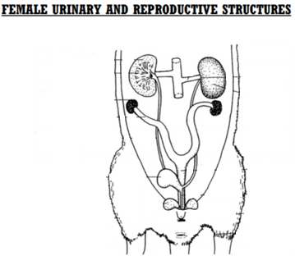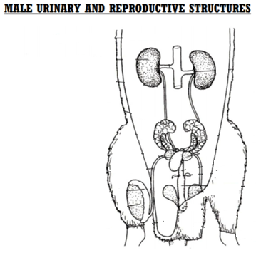

STRUCTURES

Seminal vesicle, Penis, Testes, Scrotum, Prostate gland, Vas deferens. Epididymis, Urethra

STRUCTURES

Vaginal opening, Ovary, Anus, Uterine horns, Vagina

**Rats do not have fallopian tube.

Uterus is called uterine horn.

**Part E: Discussion** **(6 marks)**

Discuss the role of the rat reproductive system and explain any differences between humans and rats. Make sure you include what you learnt from the dissection and any other relevant information.